### 

### Semester One Examination, 2018

### Question/Answer booklet

# Yr 12 SPECIALIST

**UNIT 3**

## Section Two:

## Calculator-assumed

|  |
| --- |
|  |

Your Name

Your Teacher’s Name

## Time allowed for this section

Reading time before commencing work: ten minutes

Working time: one hundred minutes

## Materials required/recommended for this section

***To be provided by the supervisor***

This Question/Answer booklet

Formula sheet (retained from Section One)

***To be provided by the candidate***

Standard items: pens (blue/black preferred), pencils (including coloured), sharpener, correction fluid/tape, eraser, ruler, highlighters

Special items: drawing instruments, templates, notes on two unfolded sheets of A4 paper, and up to three calculators approved for use in this examination

## Important note to candidates

No other items may be taken into the examination room. It is **your** responsibility to ensure that you do not have any unauthorised material. If you have any unauthorised material with you, hand it to the supervisor **before** reading any further.

|  |  |  |  |
| --- | --- | --- | --- |
| **Question** | **Marks** | **Question** | **Marks** |
| **9** |  | **16** |  |
| **10** |  | **17** |  |
| **11** |  | **18** |  |
| **12** |  | **19** |  |
| **13** |  | **20** |  |
| **14** |  | **21** |  |
| **15** |  |

**Structure of this paper**

|  |  |  |  |  |  |
| --- | --- | --- | --- | --- | --- |
| Section | Number of questions available | Number of questions to be answered | Working time (minutes) | Marks available | Percentage of examination |
| Section One:  Calculator-free | 8 | 8 | 50 | 50 | 35 |
| Section Two:  Calculator-assumed | 21 | 21 | 100 | 95 | 65 |
|  |  |  |  | **Total** | 100 |

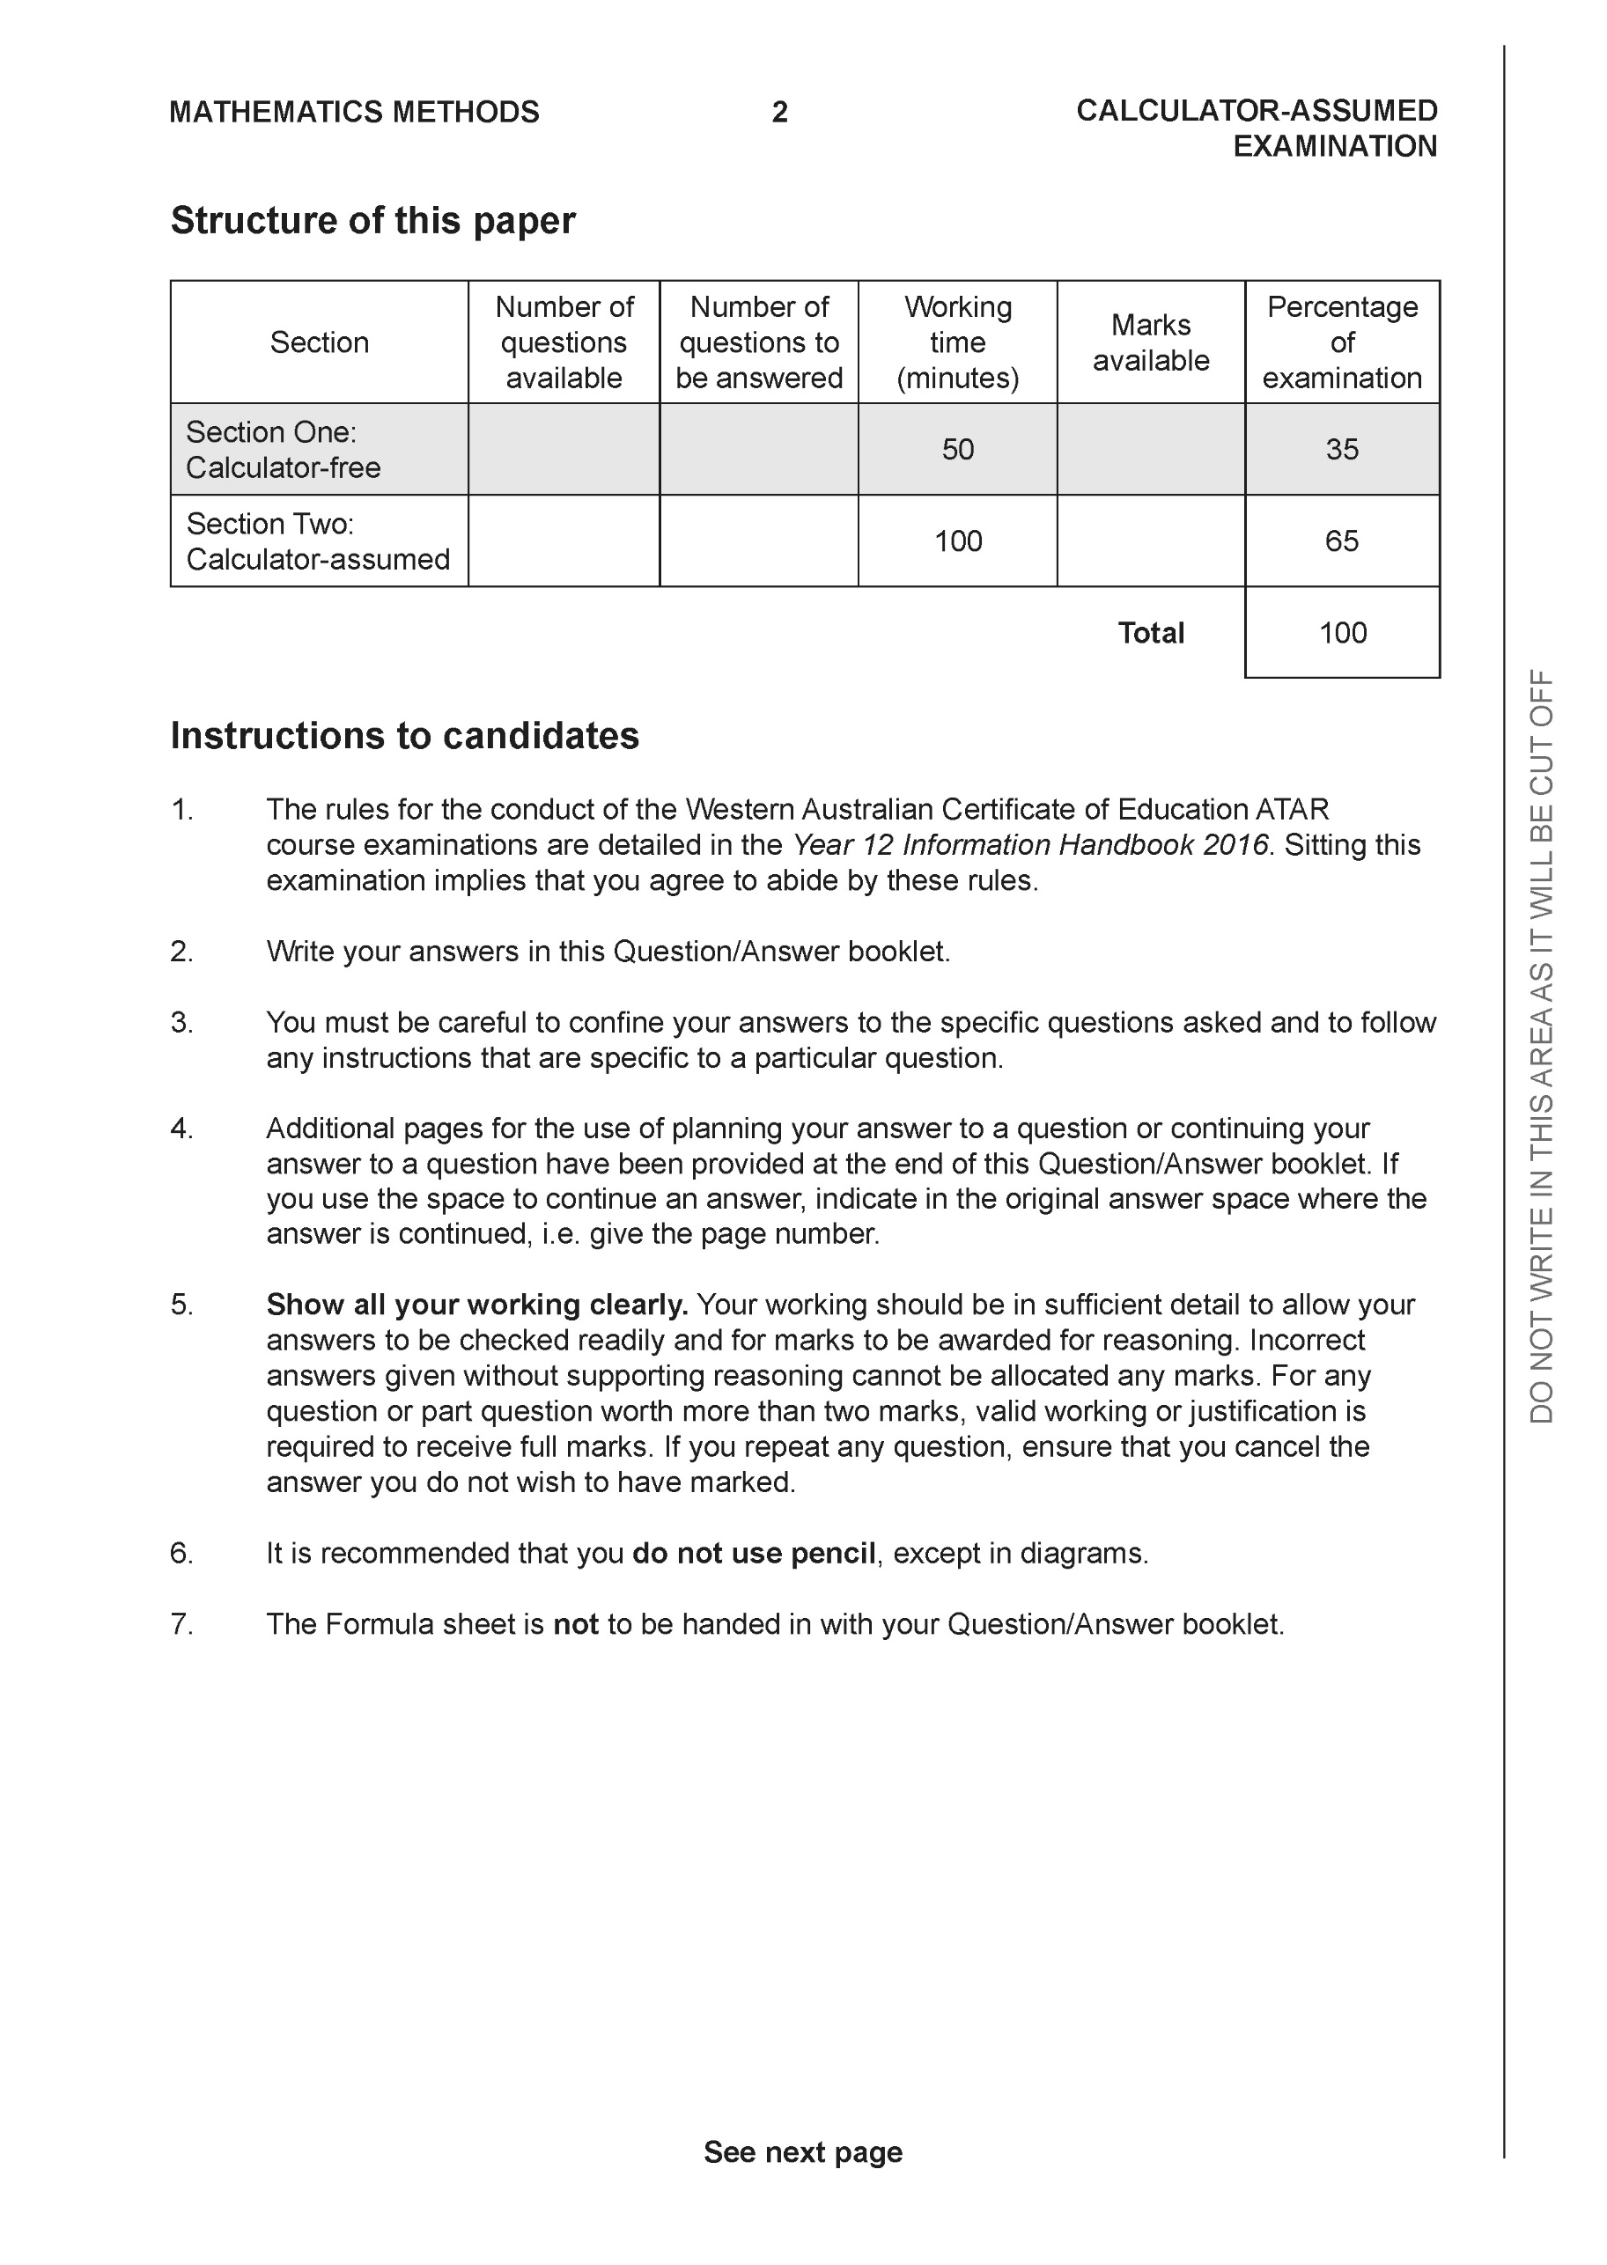

**Section Two: Calculator-assumed (95 Marks)**

This section has **13** questions. Answer **all** questions. Write your answers in the spaces provided.

Spare pages are included at the end of this booklet. They can be used for planning your responses and/or as additional space if required to continue an answer.

● Planning: If you use the spare pages for planning, indicate this clearly at the top of the page.

● Continuing an answer: If you need to use the space to continue an answer, indicate in the original answer space where the answer is continued, i.e. give the page number. Fill in the number of the question that you are continuing to answer at the top of the page.

Working time: 100 minutes.

**Question 9 (4 marks)**

Using vectors and the vector property  , prove the following inequality



**Question 10 (9 marks)**

Consider the following system of linear equations where  are constants.



Determine the values of :

(a) for which there is a unique solution (4 marks)

(b) for which there are infinite solutions. (3 marks)

(c) for which there are no solutions. (2 marks)

**Question 11 (4 marks)**

Consider the plane  as shown below.

Determine the distance of point P  from the plane to two decimal places.

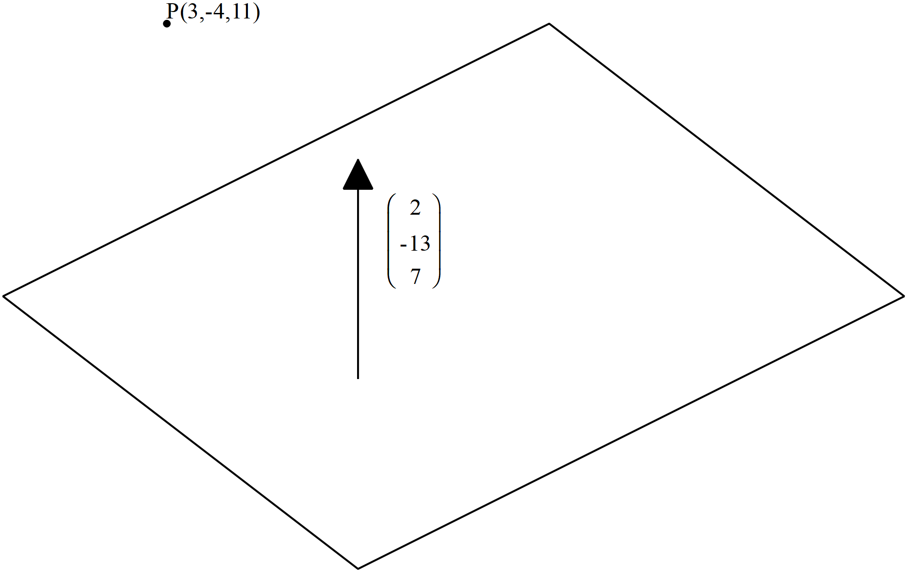

**Question 12 (4 marks)**

Given that  use cross product to determine the distance of point P  from the line  to one decimal place.

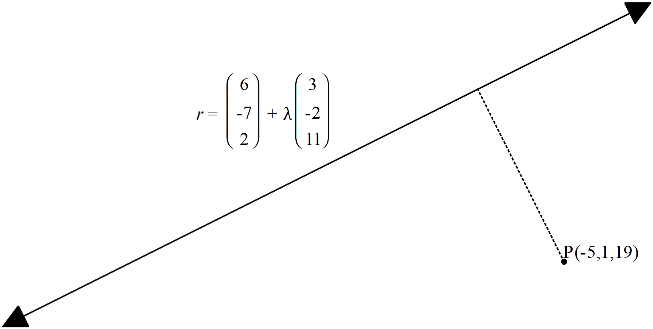

**Question 13 (4 marks)**

The three vertices of a triangle have position vectors . Given that 

Show that the area of the triangle is given by 

**Question 14 (6 marks)**

Consider the polynomial  where  are real constants. Determine the values of given the following information for 

 is a factor of .

When is divided by  there is a remainder of 165

 and 

**Question 15 (9 marks)**

At noon a rocket is launched from position  km with a velocity of  km/h.

Two hours later a second rocket is launched from position  km with a velocity of  km/h.

Assume that both rockets move with constant velocity at all times and that the rockets

do not collide.

(a) Determine the distance between the rockets at 2:30pm that day to one decimal place.

(3 marks)

(b) Determine the times that the distance between the rockets is less than 50 km.

(4 marks)

(c) Determine the distance of closest approach and the time that this occurs. (2 marks)

**Question 16 (9 marks)**

Consider the complex numbers drawn in the complex plane below.

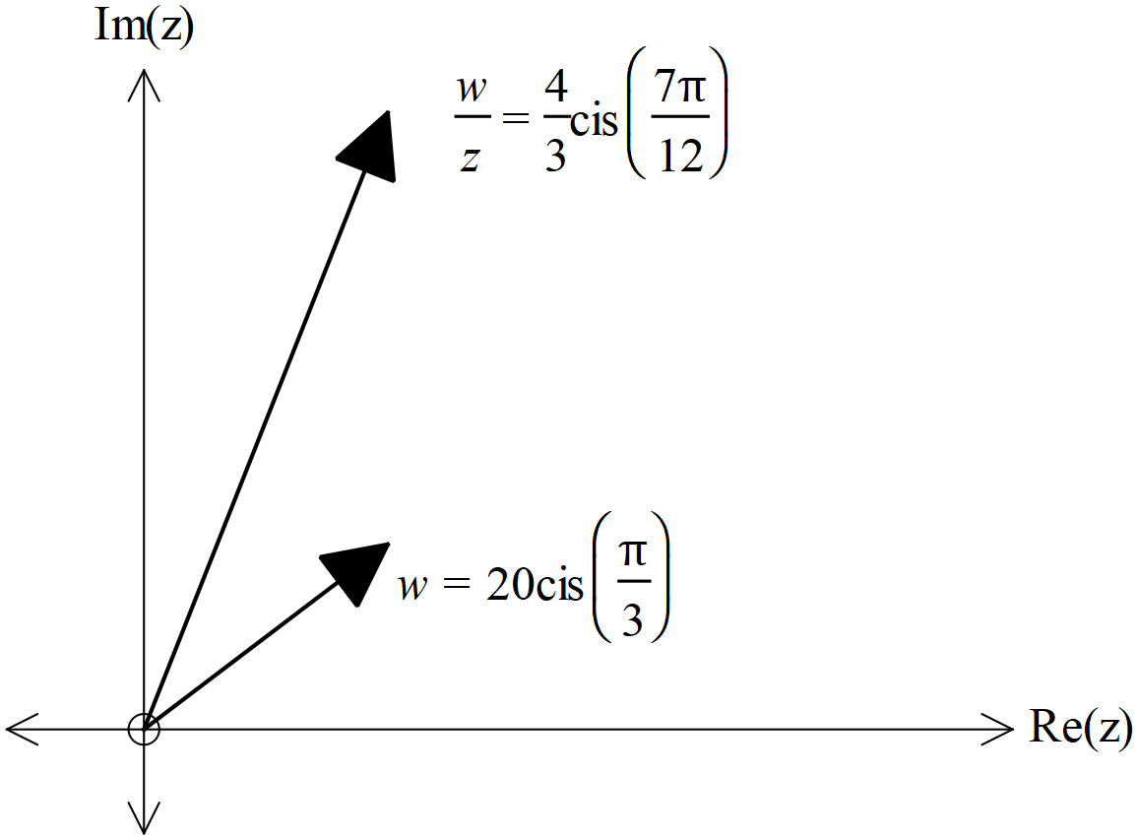

(a) Determine the exact value of  in the form of  (3 marks)

Consider the equation 

where  and 

(b) Represent the above equation as a triangle in the complex plane below (3 marks)

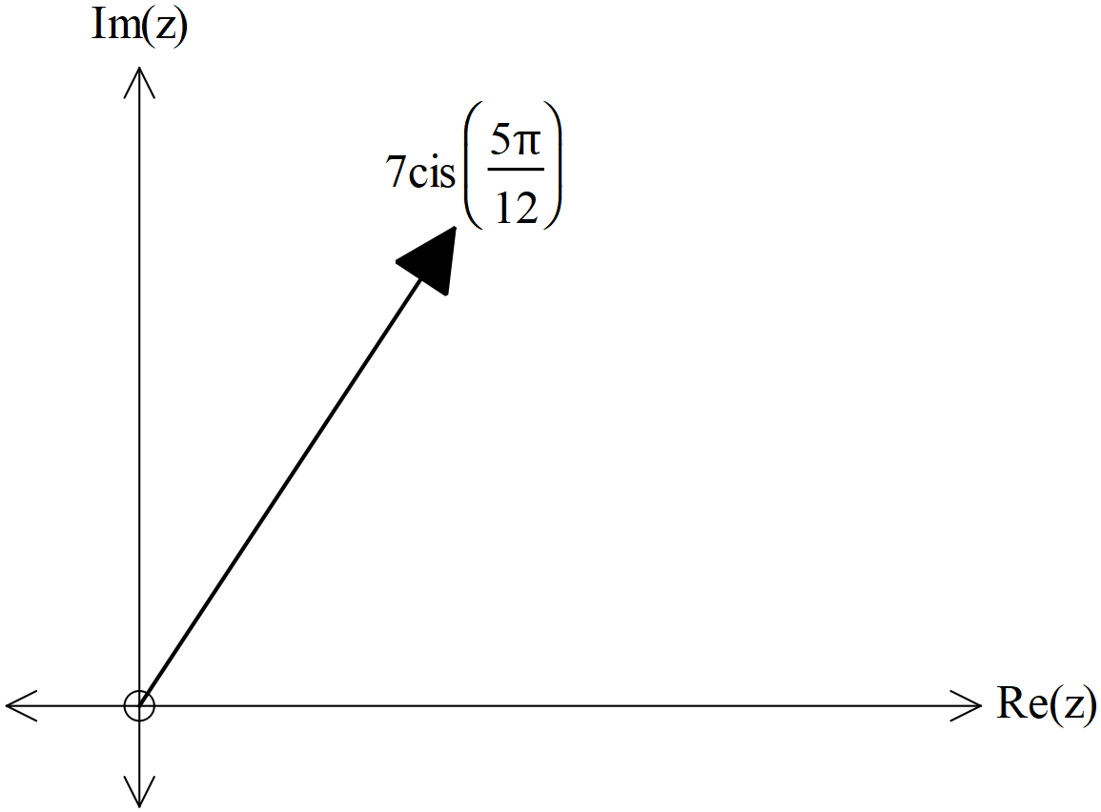

Cont-

(c) Hence or otherwise solve for  to one decimal place. (3 marks)

**Question 17 (9 marks)**

Consider a sphere with centre  and radius of  units.

(a) Write down the vector equation for this sphere (2 marks)

Consider a line parallel to vector  and containing the point 

where  is a constant.

(b) Write down the vector equation of the line in terms of . (2 marks)

(c) Determine the possible values of , to 2 decimal places, if the line is a tangent to the sphere..

(5 marks)

**Question 18 (11 marks)**

A particle moves with acceleration  at time  seconds. The initial velocity is  and initial displacement of .

(a) Determine the time(s),, that the particle is travelling parallel to the y axis.

(4 marks)

(b) Determine the first two times that the particle crosses the y axis. (4 marks)

(c) Determine the cartesian equation of the path of a new particle with the following position vector  (3 marks)

**Question 19 (9 marks)**

Consider the function  where  and

 are positive constants with 

(a) Given that the inverse function does exist obtain an expression for 

in terms of  (3 marks)

(b) Given that there is only one point where  determine the x value

in terms of  (3 marks)

(c) Given that  and ,

determine the function  in terms of  (3 marks)

**Question 20 (11 marks)**

Consider  drawn below, where each face is a parallelogram. Let  ,  and  with  perpendicular to plane containing vectors .

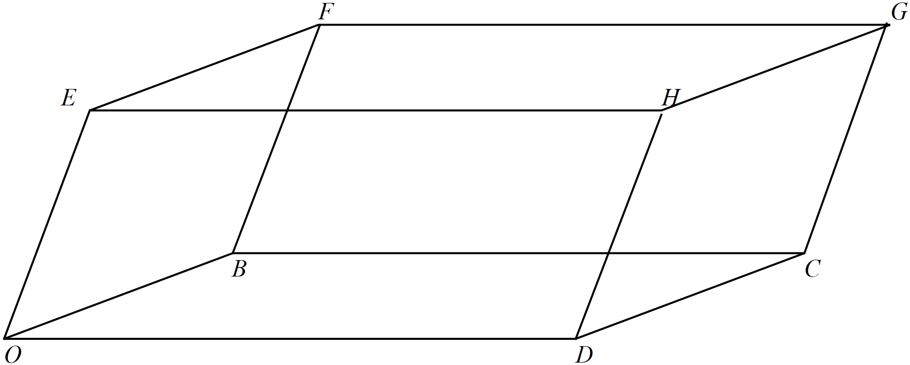

(a) Express each of the vectors  in terms of 

(4 marks)

(b) Express  in terms of  (4 marks)

Cont-

(c) Hence show that 

(3 marks)

**Question 21 (6 marks)**

Consider the region defined by  in the complex plane.

(a) Sketch the region on the axes below. (3 marks)

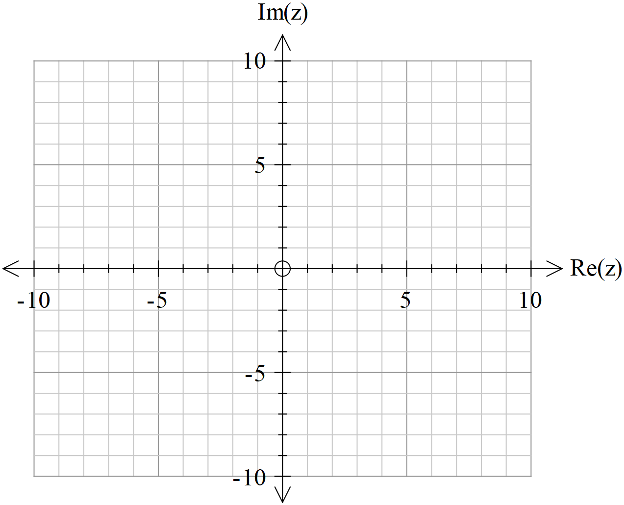

(b) Given that , determine the minimum value of 

In the region in (a).(Give to two decimal places) (3 marks)

Additional working space

Question number:

Additional working space

Question number:

Additional working space

Question number:

Additional working space

Question number: